**Minikube Installation**

Reference website

<https://minikube.sigs.k8s.io/docs/start/?arch=%2Flinux%2Fx86-64%2Fstable%2Fbinary+download>

Launch Instance with t3.xlarge instance type

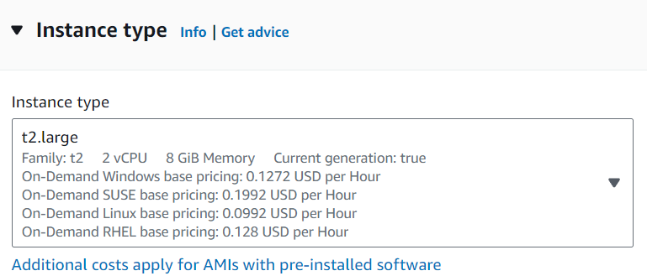

**Install docker with script docker.sh**

minikube start --driver=docker

#!/bin/bash

sudo apt-get update

sudo apt-get install ca-certificates curl -y

sudo install -m 0755 -d /etc/apt/keyrings

sudo curl -fsSL https://download.docker.com/linux/ubuntu/gpg -o /etc/apt/keyrings/docker.asc

sudo chmod a+r /etc/apt/keyrings/docker.asc

echo \

"deb [arch=$(dpkg --print-architecture) signed-by=/etc/apt/keyrings/docker.asc] https://download.docker.com/linux/ubuntu \

$(. /etc/os-release && echo "$VERSION_CODENAME") stable" | \

sudo tee /etc/apt/sources.list.d/docker.list > /dev/null

sudo apt-get update

sudo apt-get install docker-ce docker-ce-cli containerd.io docker-buildx-plugin docker-compose-plugin -y

Give Executable permission to other & execute

sudo chmod o+x docker.sh

sudo ./docker.sh

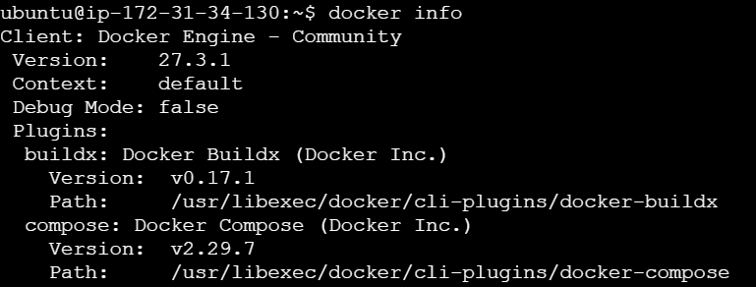

To install the latest minikube **stable** release on **x86-64** **Linux** using **binary download**:

$ curl -LO <https://storage.googleapis.com/minikube/releases/latest/minikube-linux-amd64>



$ sudo install minikube-linux-amd64 /usr/local/bin/minikube && rm minikube-linux-amd64

$ minikube start

Note – it showing driver error so enter given command

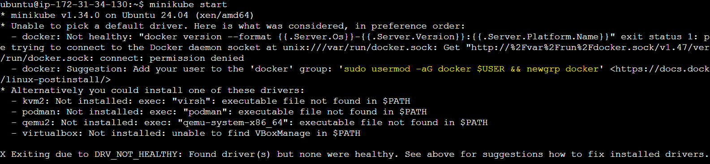

$ sudo usermod -aG docker $USER && newgrp docker

$ minikube start

Finally check minikube status-

$ minikube status

